AUTHENTICATION AND ACCESS CONTROL

Q1. Create a simple login form for a mock Zomato admin panel that asks for username and password, then displays 'Access Granted' only if both fields match hardcoded admin credentials.
Ans.
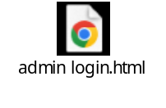
- Here’s I have attached a html file for the Zomato Admin Panel
Q2. Write a Python function check_access(user_role, resource) that returns True if the user_role is allowed to access the resource, otherwise False. Test it with roles like 'customer', 'restaurant_owner', and resources like 'menu_edit', 'order_history', 'admin_dashboard'. Hint: Use a dictionary to map roles to allowed resources.
Ans
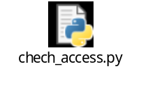
- Here’s I have attached a python file for the following task.
Q3. Simulate a two-factor authentication flow like Paytm: after a user enters the correct password, generate a 6-digit OTP and display it in the console. Ask the user to input the OTP and display 'Login Successful' only if it matches.
Ans.
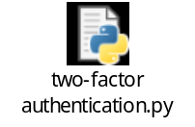
How it works:
- The user enters the correct password.
- A random 6-digit OTP is generated and displayed in the console.
- The user enters the OTP.
- “Login Successful” is displayed only when the OTP matches.

Q4. Given an array of user objects with properties: username, is Premium, and last Login, write a function that returns only those users who are premium and have logged in within the last 7 days. Constraint: Assume last Login is a date string in 'YYYY-MM-DD' format, and today is '2024-06-10'.

Ans.
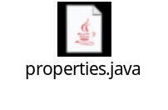
- Here’s a java file I have attached for the following task

Q5. Use ChatGPT to generate a list of 5 common access control mistakes developers make in real-world apps like Instagram or Flipkart, and for each, write a one-line fix or prevention tip.
Ans.
Mistake | One-Line Fix / Prevention
1. Broken authorization – Users can access another user’s data by changing an ID in a URL. | Always verify that the logged-in user is authorized to access the requested resource.
2. Using only frontend checks – Hiding buttons does not actually prevent unauthorized requests. | Enforce permissions on the server/API, not just in the UI.
3. Excessive permissions – Users or services receive more access than they need. | Follow the principle of least privilege and grant only necessary permissions.
4. Poor role management – Regular users accidentally receive admin-level privileges. | Centralize role/permission checks and test every role against protected functions.
5. Missing authorization checks on APIs – An endpoint works without checking the user's role or ownership. | Require authentication and authorization checks on every protected API endpoint.

- These issues are relevant to large apps such as Instagram or Flipkart because they may have many users, roles, APIs, and sensitive resources.

